Login to AWS Management Console:

Opening the Official AWS Website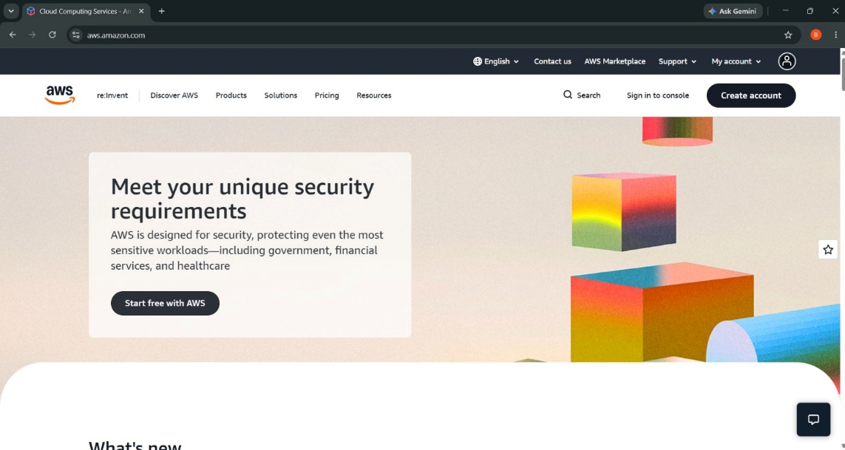
AWS IAM User Sign-In Page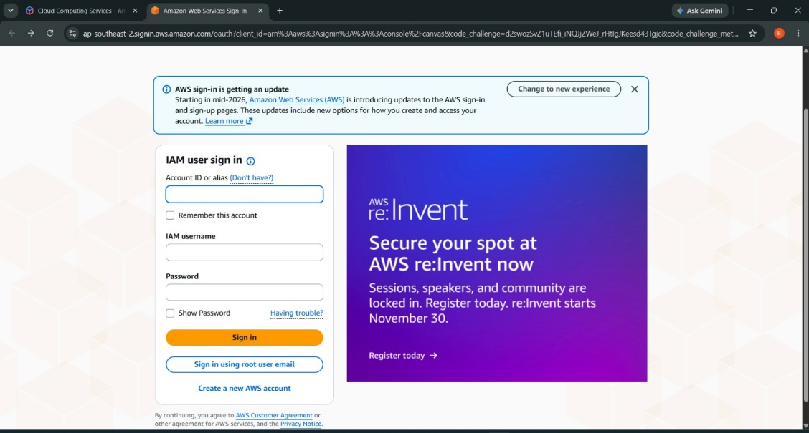
Entering Root User Email Address and AWS Account Name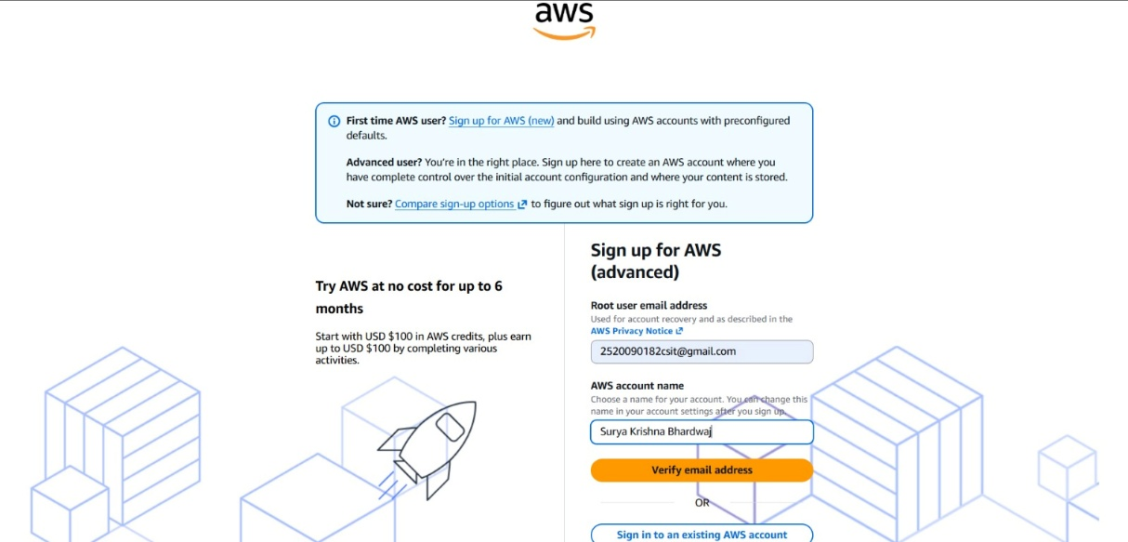
Verifying the Registered Email Address Using OTP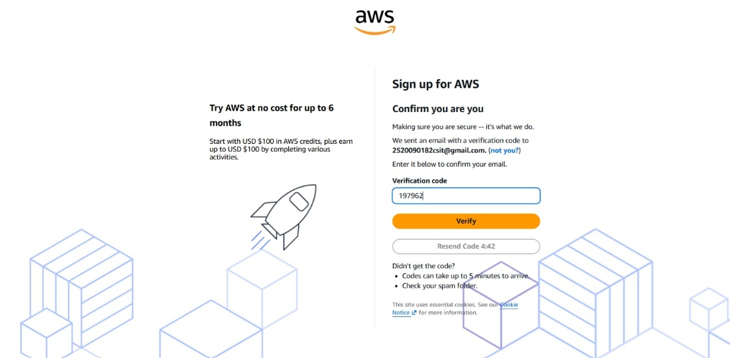
Creating and Confirming the Root User Password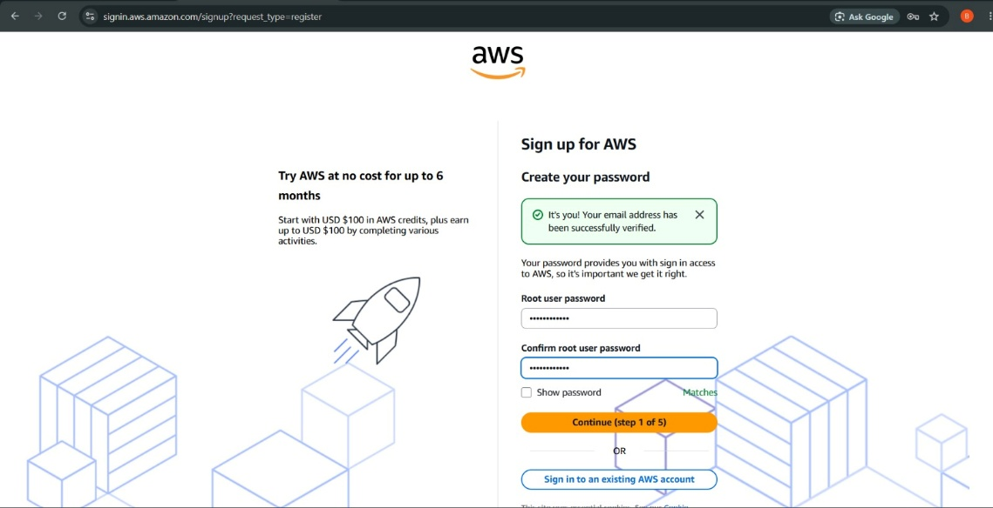
Selecting the AWS Account Plan (Free Plan)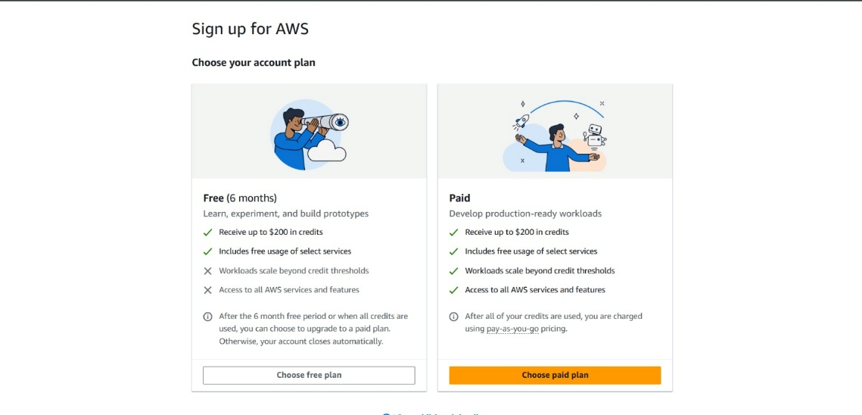
Entering Contact Information and Address Details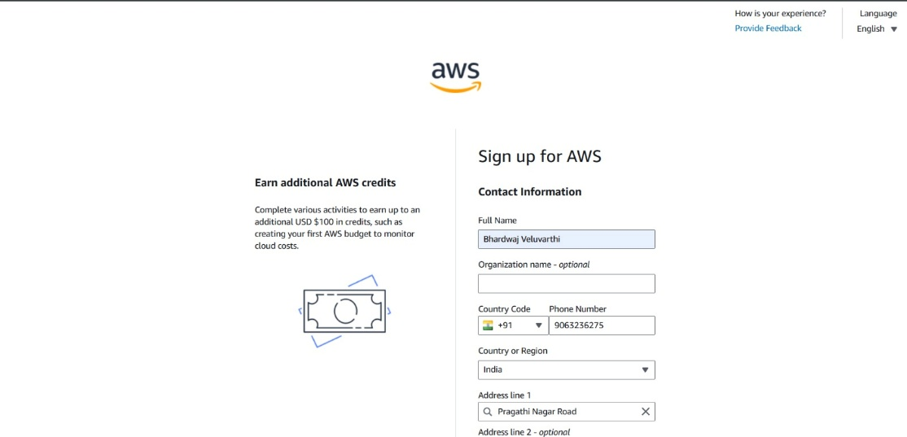
Providing AWS Billing Information and Selecting UPI AutoPay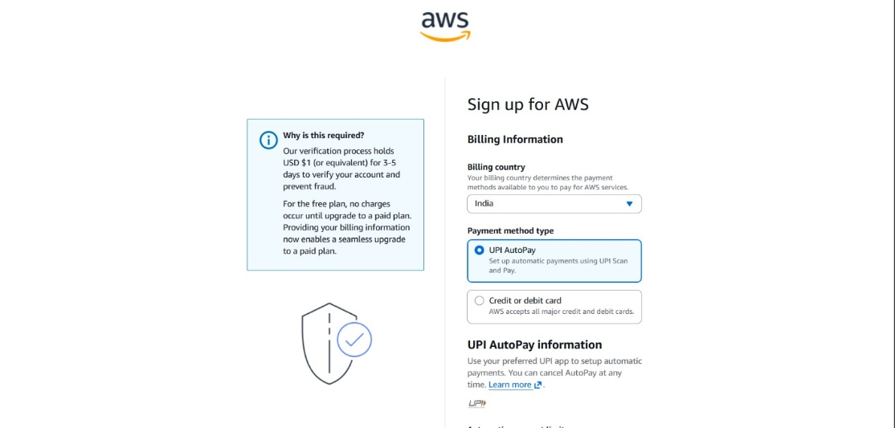
Verifying the Payment Method for AWS Account Registration

